AI Lab 1,2

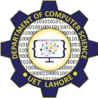

Session: 2022 – 2026

# Submitted by:

Robass Atif 2022-CS-150

# Submitted to:

Mr. Numan Shafi

Department of Computer Science

**University of Engineering and Technology Lahore Pakistan**

# Task 01



# Output



# Task 02

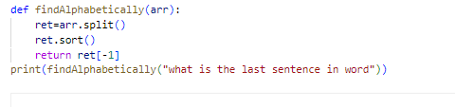

# Output

word

# Task03

# 

# Output

10

# Task 05

# 

# Output:

4

# Lab 2

# Task01

# 

# Task02

# 

# Task03

# 

# Task04

